Routes

What is route
# Source: Chatgpt (GPT‑5 Mini) at [12/14/2025]
In networking, routes are paths that data packets take to travel from a source to a destination across a network.
A route is a predefined path in a network that tells a router where to forward packets so they reach the correct destination.

How Routes Work
# Source: Chatgpt (GPT‑5 Mini) at [12/14/2025]
Routers use routing tables to store routes. Each entry tells the router:
- Destination – The IP address or network the packet wants to reach
- Next hop – The next router or gateway to forward the packet to
- Metric / Preference – Cost, priority, or efficiency of the route
When a packet arrives, the router looks up the destination IP in its routing table and forwards it along the best route.

Types of Routes
# Source: Chatgpt (GPT‑5 Mini) at [12/14/2025]
1. Static Routes
- Manually configured by a network administrator
- Simple and predictable
- Example:
Destination: 192.168.2.0/24
Next Hop: 192.168.1.2
2. Dynamic Routes
- Automatically learned by routers using routing protocols
- Can adapt to network changes
- Examples:
  - RIP (Routing Information Protocol)
  - OSPF (Open Shortest Path First)
  - BGP (Border Gateway Protocol)
3. Default Route
- A route used when no specific match is found in the routing table
- Often points to the internet gateway

Routes in BGP (Border Gateway Protocol)
# Source: Chatgpt (GPT‑5 Mini) at [12/14/2025]
- In BGP, routes are advertised between Autonomous Systems (AS)
- Each route includes:
  - Destination network
  - Path of ASes the packet should traverse
  - Policies or preferences to influence route selection

Simple Analogy
# Source: Chatgpt (GPT‑5 Mini) at [12/14/2025]
- Route = Directions on a map
- Router = GPS device
- Packet = Traveler
- The route tells the packet which path to take to reach the destination.

✅ Key Point:
# Source: Chatgpt (GPT‑5 Mini) at [12/14/2025]
A route is essentially a path in a network, and routers use routing tables and policies to decide which route to use for forwarding packets.

Routing Table

🧭 What Is a Routing Table?
# Source: Chatgpt (GPT‑5 Mini) at [12/14/2025]
A routing table is a data structure used by routers and network devices to determine the best path for forwarding packets to their destination IP addresses.
It acts like a navigation map for the internet or any IP-based network.

🧠 Simple Definition:
# Source: Chatgpt (GPT‑5 Mini) at [12/14/2025]
A routing table tells a router where to send packets, based on the destination IP address in each packet.

📦 What’s Inside a Routing Table?
# Source: Chatgpt (GPT‑5 Mini) at [12/14/2025]
Each entry in a routing table usually includes:
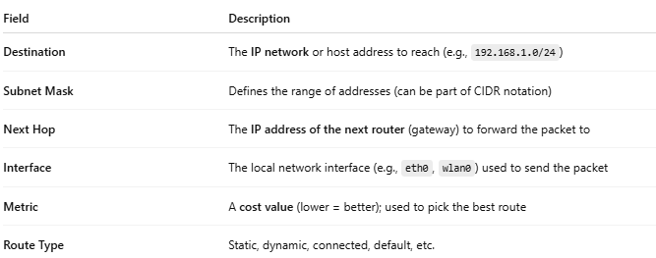
Field | Description
Destination | The IP network or host address to reach (e.g., 192.168.1.0/24)
Subnet Mask | Defines the range of addresses (can be part of CIDR notation)
Next Hop | The IP address of the next router (gateway) to forward the packet to
Interface | The local network interface (e.g., eth0, wlan0) used to send the packet
Metric | A cost value (lower = better); used to pick the best route
Route Type | Static, dynamic, connected, default, etc.

🧾 Example Routing Table (Simplified)
# Source: Chatgpt (GPT‑5 Mini) at [12/14/2025]
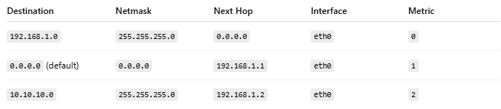
Destination | Netmask | Next Hop | Interface | Metric
192.168.1.0 | 255.255.255.0 | 0.0.0.0 | eth0 | 0
0.0.0.0 (default) | 0.0.0.0 | 192.168.1.1 | eth0 | 1
10.10.10.0 | 255.255.255.0 | 192.168.1.2 | eth0 | 2
🟡 0.0.0.0 → represents the default route, used when no better match is found.

🔄 Types of Routes
# Source: Chatgpt (GPT‑5 Mini) at [12/14/2025]
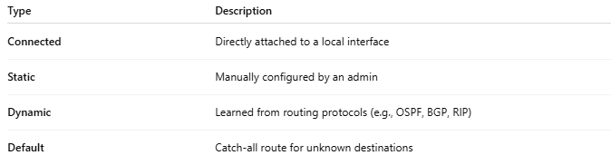
Type | Description
Connected | Directly attached to a local interface
Static | Manually configured by an admin
Dynamic | Learned from routing protocols (e.g., OSPF, BGP, RIP)
Default | Catch-all route for unknown destinations

🔧 On a Real System (Linux Example):
# Source: Chatgpt (GPT‑5 Mini) at [12/14/2025]
You can view it with:
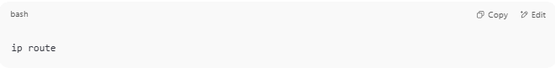
ip route

Output:
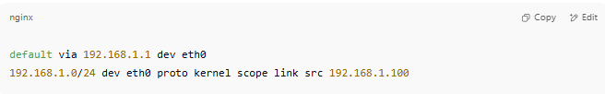
default via 192.168.1.1 dev eth0
192.168.1.0/24 dev eth0 proto kernel scope link src 192.168.1.100

✅ Summary
# Source: Chatgpt (GPT‑5 Mini) at [12/14/2025]
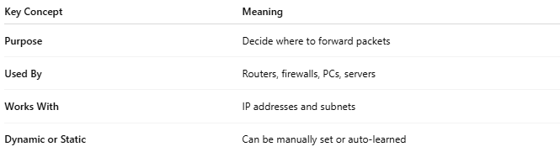
Key Concept | Meaning
Purpose | Decide where to forward packets
Used By | Routers, firewalls, PCs, servers
Works With | IP addresses and subnets
Dynamic or Static | Can be manually set or auto-learned

